
Computer Science and Information Management Program/ICT Department
School of Engineering and Technology
Asian Institute of Technology

Name __________________
ID No. __________________

AT71.03: E-Business Development and Technology August 2024 Semester
MID-SEM EXAM
Date: 26 September 2024

Time: 13.00-16.00hr (100 points)

This exam is an open exam – open notes, open books, and open Internet.

However, discussion/communication with other people AND the use of generative AI (ChatGPT, BERT, etc.) are NOT allowed. If you do so it is considered cheating, with severe punishments.

INSTRUCTIONS:
- Please acknowledge the receipt of the final exam questions IMMEDIATELY by reply email.
- There are 5 questions in the exam. Answer all questions.
- Please limit your answer to be less than 500 words for each question.
- Type your answers and submit the answers in a PDF file via reply email (please name your file as MidsemExamEBDT_YourName)
- If you draw a figure, you can save it in a separate file.
- Please put all references for all online/offline resources that you use to answer the questions.
- You can make any assumptions, as needed.
- NO submission will be accepted after 4.10pm (Thailand time) on 26 September 2024.

1) Luxury Marketing (20 points)

You are to select one luxury brand and suggest the company how to embrace digital marketing to drive more revenue and increase their profitability. Your task is to develop a digital marketing/advertising plan, including major activities, targeted customers, and digital content. Also, discuss how to measure the customer interaction through digital marketing.

2. Dollar Shave Club (https://us.dollarshaveclub.com) (20 points)

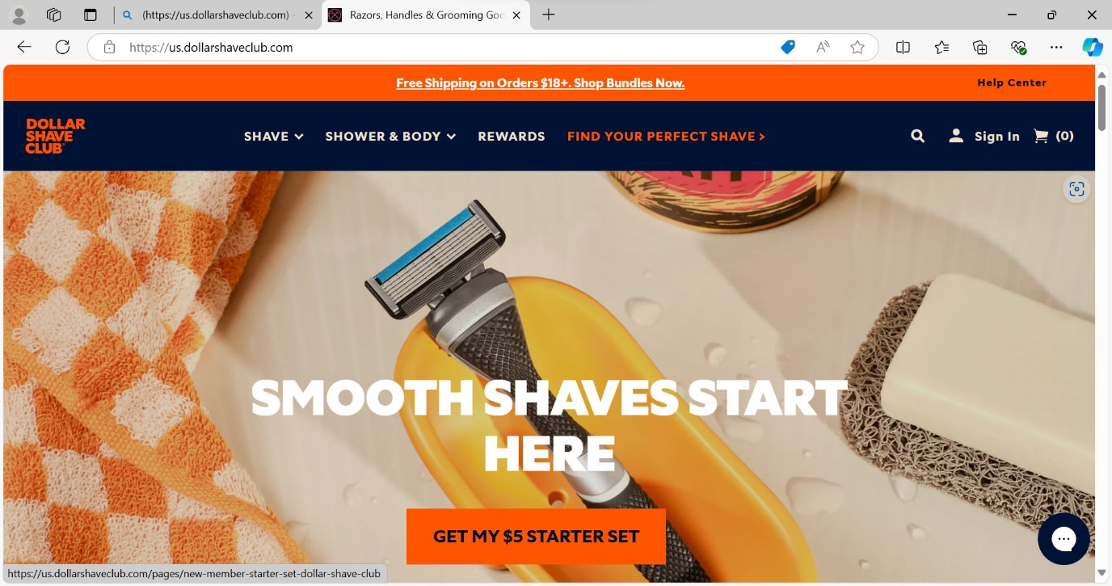

In the past decade, the disruptive influence of the Internet and the mobile platform has reshaped many industries. Traditional retailers find themselves under threat from a host of unexpected startups. One of the unexpected success stories is the rise of Dollar Shave Club from a small startup with a viral video promoting a low cost razor blades to a $1 billion company in less than five years.

Modern entrepreneurs are searching for markets where unfairness or inefficiency, but cannot do much about it. The US market for razor blades in 2012 was exactly that type of market. Gillette held a 72% market share for and its near-monopoly power to great advantage, charging as much as 167% markups for razor blades. Originally, Gillette, Schick, and other razor manufacturers disrupted the business model in their industry by offering razors at low cost, and then selling replacement blades at a significant markup, allowing them to make money indefinitely. Today, Dollar Shave Club is disrupting them.

Michael Dubin, Dollar Shave Club’s founder, saw an opportunity. Dubin’s road map for Dollar Shave Club was as follows: first, his company would use a subscription-based model that would allow customers to order razors and blades sent directly to their homes for as little as $1 a month before shipping. The company’s razors are made inexpensively in South Korea. Cutting out retail outlets creates savings, passing on to its customers. Next, Dubin wanted to create a lifestyle brand as opposed to a simple delivery service, illustrating its contrast with the bigger brands.

Fast forward to 2019, and Gillette’s share of the US razor market had dropped significantly, to 53%, due almost entirely to Dollar Shave Club and similar subscription-based companies. Currently, it has an estimated 4 million subscribers.

Dollar Shave Club prioritizes unscripted customer service: real live people as opposed to automated systems and interfaces. In addition, the company uses member feedback to make a decision regarding its product line. Dollar Shave Club’s commitments to its brand and to its members has made the company’s customer base extremely loyal.
2.1 Describe a business model of Dollar Shave Club. How does it differ from its competitors?
2.2 What are the key elements of Dollar Shave Club’s value proposition for customers?

3. Personalization and Customization (20 points)

Discuss and give some examples of both personalization and customization for the following two online businesses.
a) Online Shop for Sportwear
b) Online Insurance Service

In order to answer this question, you should select a particular online shop and a particular online insurance service.

4. B2B Marketplace (20 points)

Joor (https://www.joor.com) is a global wholesale fashion marketplace that connects top brands with retailers. Given the power of international wholesale using JOOR, it is a B2B digital platform that offers a seamless buying experience and helps to connect global retailers with fashion brands from around the world.

Joor also faces the well-known chicken egg problem of online marketplace here is whom to attract first: retailers or fashion brands. The chicken and egg problem describes a specific challenge of building an initial user base for online marketplaces. How do you bring in customers when you don’t yet have sellers, or sellers when you don’t have customers?

Questions:
  - Should Joor focus on attracting retailers (customers) or fashion brands (sellers) first? Justify your answer.

  - Describe the value that Joor can offer to retailers and fashion brands. What concerns retailers and fashion brands would have about joining Joor?

5. Webite/Mobile App (20 points)

What is your favorite e-commerce website or mobile app, in term of user experience, and why do you like it?

What do you think are the characteristics of a really effective e-commerce experience?

NAME___________________

Answer - Question 1

NAME___________________
Answer - Question 2

NAME___________________

Answer - Question 3

NAME___________________

Answer - Question 4

NAME___________________

Answer - Question 5

References

